Chapter 07
Capital Asset Pricing and Arbitrage Pricing Theory

- The required rate of return on a stock is related to the required rate of return on the stock market via beta. Assuming the beta of Google remains constant, the increase in the risk of the market will increase the required rate of return on the market, and thus increase the required rate of return on Google.

- An example of this scenario would be an investment in the SMB and HML. As of yet, there are no vehicles (index funds or ETFs) to directly invest in SMB and HML. While they may prove superior to the single index model, they are not yet practical, even for professional investors.

- The APT may exist without the CAPM, but not the other way. Thus, statement a is possible, but not b. The reason being, that the APT accepts the principle of risk and return, which is central to CAPM, without making any assumptions regarding individual investors and their portfolios. These assumptions are necessary to CAPM.

- E(r_{P}) = r_{f} + β[E(r_{M}) – r_{f}]
20% = 5% + β(15% – 5%) ⇒ β = 15/10 = 1.5
- If the beta of the security doubles, then so will its risk premium. The current risk premium for the stock is: (13% - 7%) = 6%, so the new risk premium would be 12%, and the new discount rate for the security would be: 12% + 7% = 19%

If the stock pays a constant dividend in perpetuity, then we know from the original data that the dividend (D) must satisfy the equation for a perpetuity:

Price = Dividend/Discount rate
40 = D/0.13 ⇒ D = 40 × 0.13 = $5.20
At the new discount rate of 19%, the stock would be worth: $5.20/0.19 = $27.37
The increase in stock risk has lowered the value of the stock by 31.58%.

- The cash flows for the project comprise a 10-year annuity of $10 million per year plus an additional payment in the tenth year of $10 million (so that the total payment in the tenth year is $20 million). The appropriate discount rate for the project is:
r_{f} + β[E(r_{M}) – r_{f} ] = 9% + 1.7(19% – 9%) = 26%
Using this discount rate:
NPV = –20 + 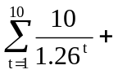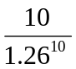

= –20 + [10 × Annuity factor (26%, 10 years)] + [10 × PV factor (26%, 10 years)]
= 15.64
The internal rate of return on the project is 49.55%. The highest value that beta can take before the hurdle rate exceeds the IRR is determined by:
49.55% = 9% + β(19% – 9%) ⇒ β = 40.55/10 = 4.055

  - False. β = 0 implies E(r) = r_{f} , not zero.

  - False. Investors require a risk premium for bearing systematic (i.e., market or undiversifiable) risk.

  - False. You should invest 0.75 of your portfolio in the market portfolio, and the remainder in T-bills. Then:
β_{P} = (0.75 × 1) + (0.25 × 0) = 0.75

  - The beta is the sensitivity of the stock's return to the market return. Call the aggressive stock A and the defensive stock D. Then beta is the change in the stock return per unit change in the market return. We compute each stock's beta by calculating the difference in its return across the two scenarios divided by the difference in market return.
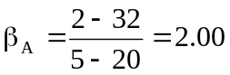
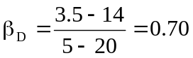
  - With the two scenarios equal likely, the expected rate of return is an average of the two possible outcomes:
E(r_{A}) = 0.5 × (2% + 32%) = 17%
E(r_{B}) = 0.5 × (3.5% + 14%) = 8.75%
  - The SML is determined by the following: T-bill rate = 8% with a beta equal to zero, beta for the market is 1.0, and the expected rate of return for the market is:
0.5 × (20% + 5%) = 12.5%
See the following graph.
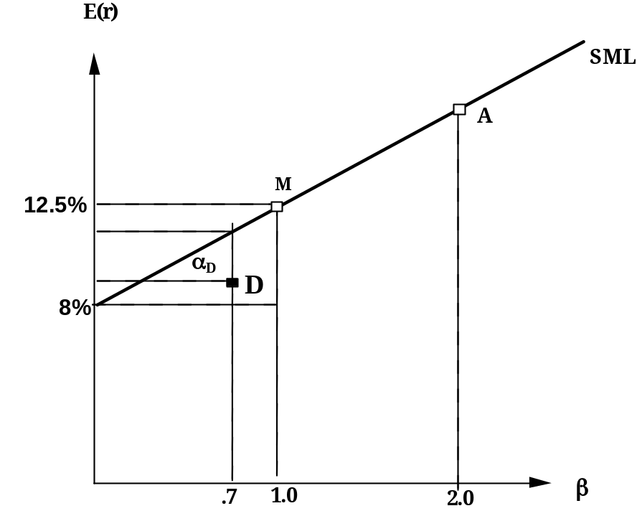
The equation for the security market line is: E(r) = 8% + β(12.5% – 8%)
  - The aggressive stock has a fair expected rate of return of:
E(r_{A}) = 8% + 2.0(12.5% – 8%) = 17%
The security analyst’s estimate of the expected rate of return is also 17%. Thus the alpha for the aggressive stock is zero. Similarly, the required return for the defensive stock is:
E(r_{D}) = 8% + 0.7(12.5% – 8%) = 11.15%
The security analyst’s estimate of the expected return for D is only 8.75%, and hence:
α_{D} = actual expected return – required return predicted by CAPM
= 8.75% – 11.15% = –2.4%
The points for each stock are plotted on the graph above.
  - The hurdle rate is determined by the project beta (i.e., 0.7), not by the firm’s beta. The correct discount rate is therefore 11.15%, the fair rate of return on stock D.

- Not possible. Portfolio A has a higher beta than Portfolio B, but the expected return for Portfolio A is lower.

- Possible. If the CAPM is valid, the expected rate of return compensates only for systematic (market) risk as measured by beta, rather than the standard deviation, which includes nonsystematic risk. Thus, Portfolio A's lower expected rate of return can be paired with a higher standard deviation, as long as Portfolio A's beta is lower than that of Portfolio B.

- Not possible. The reward-to-variability ratio for Portfolio A is better than that of the market, which is not possible according to the CAPM, since the CAPM predicts that the market portfolio is the most efficient portfolio. Using the numbers supplied:
S_{A} =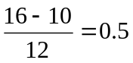
S_{M} =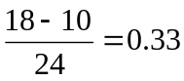
These figures imply that Portfolio A provides a better risk-reward tradeoff than the market portfolio.

- Not possible. Portfolio A clearly dominates the market portfolio. It has a lower standard deviation with a higher expected return.

- Not possible. Given these data, the SML is: E(r) = 10% + β(18% – 10%)
A portfolio with beta of 1.5 should have an expected return of:
E(r) = 10% + 1.5 × (18% – 10%) = 22%
The expected return for Portfolio A is 16% so that Portfolio A plots below the SML (i.e., has an alpha of –6%), and hence is an overpriced portfolio. This is inconsistent with the CAPM.

- Not possible. The SML is the same as in Problem 12. Here, the required expected return for Portfolio A is: 10% + (0.9 × 8%) = 17.2%
This is still higher than 16%. Portfolio A is overpriced, with alpha equal to: –1.2%

- Possible. Portfolio A's ratio of risk premium to standard deviation is less attractive than the market's. This situation is consistent with the CAPM. The market portfolio should provide the highest reward-to-variability ratio.

a.

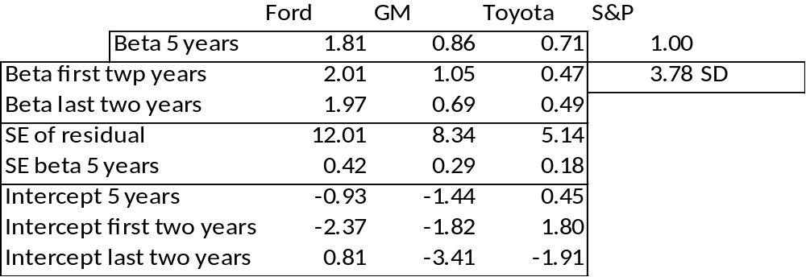

b.
As a first pass we note that large standard deviation of the beta estimates. None of the subperiod estimates deviate from the overall period estimate by more than two standard deviations. That is, the t-statistic of the deviation from the overall period is not significant for any of the subperiod beta estimates. Looking beyond the aforementioned observation, the differences can be attributed to different alpha values during the subperiods. The case of Toyota is most revealing: The alpha estimate for the first two years is positive and for the last two years negative (both large). Following a good performance in the "normal" years prior to the crisis, Toyota surprised investors with a negative performance, beyond what could be expected from the index. This suggests that a beta of around 0.5 is more reliable. The shift of the intercepts from positive to negative when the index moved to largely negative returns, explains why the line is steeper when estimated for the overall period. Draw a line in the positive quadrant for the index with a slope of 0.5 and positive intercept. Then draw a line with similar slope in the negative quadrant of the index with a negative intercept. You can see that a line that reconciles the observations for both quadrants will be steeper. The same logic explains part of the behavior of subperiod betas for Ford and GM.

- Since the stock's beta is equal to 1.0, its expected rate of return should be equal to that of the market, that is, 18%.
E(r) =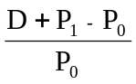
0.18 =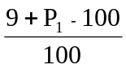⇒ P₁ = $109

- If beta is zero, the cash flow should be discounted at the risk-free rate, 8%:
PV = $1,000/0.08 = $12,500

If, however, beta is actually equal to 1, the investment should yield 18%, and the price paid for the firm should be:
PV = $1,000/0.18 = $5,555.56
The difference ($6944.44) is the amount you will overpay if you erroneously assume that beta is zero rather than 1.

- Using the SML: 6% = 8% + β(18% – 8%) ⇒ β = –2/10 = –0.2

- r₁ = 19%; r₂ = 16%; β₁ = 1.5; β₂ = 1.0
  - In order to determine which investor was a better selector of individual stocks we look at the abnormal return, which is the ex-post alpha; that is, the abnormal return is the difference between the actual return and that predicted by the SML. Without information about the parameters of this equation (i.e., the risk-free rate and the market rate of return) we cannot determine which investment adviser is the better selector of individual stocks.

  - If r_{f} = 6% and r_{M} = 14%, then (using alpha for the abnormal return):
α₁ = 19% – [6% + 1.5(14% – 6%)] = 19% – 18% = 1%
α₂ = 16% – [6% + 1.0(14% – 6%)] = 16% – 14% = 2%
Here, the second investment adviser has the larger abnormal return and thus appears to be the better selector of individual stocks. By making better predictions, the second adviser appears to have tilted his portfolio toward under-priced stocks.

  - If r_{f} = 3% and r_{M} = 15%, then:
α₁ =19% – [3% + 1.5(15% – 3%)] = 19% – 21% = –2%
α₂ = 16% – [3%+ 1.0(15% – 3%)] = 16% – 15% = 1%
Here, not only does the second investment adviser appear to be a better stock selector, but the first adviser's selections appear valueless (or worse).

  - Since the market portfolio, by definition, has a beta of 1.0, its expected rate of return is 12%.

  - β = 0 means the stock has no systematic risk. Hence, the portfolio's expected rate of return is the risk-free rate, 4%.

  - Using the SML, the fair rate of return for a stock with β= –0.5 is:
E(r) = 4% + (–0.5)(12% – 4%) = 0.0%

The expected rate of return, using the expected price and dividend for next year:
E(r) = ($44/$40) – 1 = 0.10 = 10%
Because the expected return exceeds the fair return, the stock must be under-priced.

- The data can be summarized as follows:
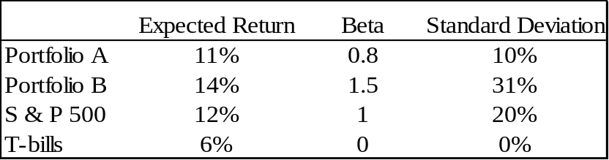

  - Using the SML, the expected rate of return for any portfolio P is:
E(r_{P}) = r_{f} + β[E(r_{M}) – r_{f} ]
Substituting for portfolios A and B:
E(r_{A}) = 6% + 0.8 × (12% – 6%) = 10.8%
E(r_{B}) = 6% + 1.5 × (12% – 6%) = 15.0%
Hence, Portfolio A is desirable and Portfolio B is not.

  - The slope of the CAL supported by a portfolio P is given by:
S = 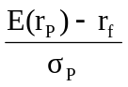
Computing this slope for each of the three alternative portfolios, we have:
S (S&P 500) = 6/20
S (A) = 5/10
S (B) = 8/31
Hence, portfolio A would be a good substitute for the S&P 500.

- Since the beta for Portfolio F is zero, the expected return for Portfolio F equals the risk-free rate.

For Portfolio A, the ratio of risk premium to beta is: (10% − 4%)/1 = 6%
The ratio for Portfolio E is higher: (9% − 4%)/(2/3) = 7.5%
This implies that an arbitrage opportunity exists. For instance, you can create a Portfolio G with beta equal to 1.0 (the same as the beta for Portfolio A) by taking a long position in Portfolio E and a short position in Portfolio F (that is, borrowing at the risk-free rate and investing the proceeds in Portfolio E). For the beta of G to equal 1.0, the proportion (w) of funds invested in E must be: 3/2 = 1.5
The expected return of G is then:
E(r_{G}) = [(−0.50) × 4%] + (1.5 × 9%) = 11.5%
β_{G} = 1.5 × (2/3) = 1.0
Comparing Portfolio G to Portfolio A, G has the same beta and a higher expected return. Now, consider Portfolio H, which is a short position in Portfolio A with the proceeds invested in Portfolio G:
β_{H} = 1β_{G} + (−1)β_{A} = (1 × 1) + [(−1) × 1] = 0
E(r_{H}) = (1 × r_{G}) + [(−1) × r_{A}] = (1 × 11.5%) + [(− 1) × 10%] = 1.5%
The result is a zero investment portfolio (all proceeds from the short sale of Portfolio A are invested in Portfolio G) with zero risk (because β = 0 and the portfolios are well diversified), and a positive return of 1.5%. Portfolio H is an arbitrage portfolio.

- Substituting the portfolio returns and betas in the expected return-beta relationship, we obtain two equations in the unknowns, the risk-free rate (r_{f} ) and the factor return (F):
14.0% = r_{f} + 1 × (F – r_{f} )
14.8% = r_{f} + 1.1 × (F – r_{f} )
From the first equation we find that F = 14%. Substituting this value for F into the second equation, we get:
14.8% = r_{f} + 1.1 × (14% – r_{f} ) ⇒ r_{f} = 6%

  - Shorting equal amounts of the 10 negative-alpha stocks and investing the proceeds equally in the 10 positive-alpha stocks eliminates the market exposure and creates a zero-investment portfolio. Using equation 7.5, and denoting the market factor as R_{M}, the expected dollar return is [noting that the expectation of residual risk (e) in equation 7.8 is zero]:
$1,000,000 × [0.03 + (1.0 × R_{M})] – $1,000,000 × [(–0.03) + (1.0 × R_{M})]
= $1,000,000 × 0.06 = $60,000
The sensitivity of the payoff of this portfolio to the market factor is zero because the exposures of the positive alpha and negative alpha stocks cancel out. (Notice that the terms involving R_{M} sum to zero.) Thus, the systematic component of total risk also is zero. The variance of the analyst's profit is not zero, however, since this portfolio is not well diversified.
For n = 20 stocks (i.e., long 10 stocks and short 10 stocks) the investor will have a $100,000 position (either long or short) in each stock. Net market exposure is zero, but firm-specific risk has not been fully diversified. The variance of dollar returns from the positions in the 20 firms is:
20 × [(100,000 × 0.30)²] = 18,000,000,000
The standard deviation of dollar returns is $134,164.

  - If n = 50 stocks (i.e., 25 long and 25 short), $40,000 is placed in each position, and the variance of dollar returns is:
50 × [(40,000 × 0.30)²] = 7,200,000,000
The standard deviation of dollar returns is $84,853.
Similarly, if n = 100 stocks (i.e., 50 long and 50 short), $20,000 is placed in each position, and the variance of dollar returns is:
100 × [(20,000 × 0.30)²] = 3,600,000,000
The standard deviation of dollar returns is $60,000.
Notice that when the number of stocks increases by a factor of 5 (from 20 to 100), standard deviation falls by a factor of = 2.236, from $134,164 to $60,000.

- Any pattern of returns can be "explained" if we are free to choose an indefinitely large number of explanatory factors. If a theory of asset pricing is to have value, it must explain returns using a reasonably limited number of explanatory variables (i.e., systematic factors).

- The APT factors must correlate with major sources of uncertainty, i.e., sources of uncertainty that are of concern to many investors. Researchers should investigate factors that correlate with uncertainty in consumption and investment opportunities. GDP, the inflation rate and interest rates are among the factors that can be expected to determine risk premiums. In particular, industrial production (IP) is a good indicator of changes in the business cycle. Thus, IP is a candidate for a factor that is highly correlated with uncertainties related to investment and consumption opportunities in the economy.

- The revised estimate of the expected rate of return of the stock would be the old estimate plus the sum of the unexpected changes in the factors times the sensitivity coefficients, as follows:
Revised estimate = 14% + [(1 × 1) + (0.4 × 1)] = 15.4%

- Equation 7.11 applies here:
E(r_{P}) = r_{f} + β_{P1}[E(r₁) − r_{f}] + β_{P2}[E(r₂) – r_{f}]
We need to find the risk premium for these two factors:
γ₁ = [E(r₁) − r_{f}] and
γ₂ = [E(r₂) − r_{f}]

To find these values, we solve the following two equations with two unknowns:
40% = 7% + 1.8γ₁ + 2.1γ₂
10% = 7% + 2.0γ₁ + (−0.5)γ₂
The solutions are: γ₁ = 4.47% and γ₂ = 11.86%
Thus, the expected return-beta relationship is:
E(r_{P}) = 7% + 4.47β_{P1} + 11.86β_{P2}

- The first two factors (the return on a broad-based index and the level of interest rates) are most promising with respect to the likely impact on Jennifer’s firm’s cost of capital. These are both macro factors (as opposed to firm-specific factors) that can not be diversified away; consequently, we would expect that there is a risk premium associated with these factors. On the other hand, the risk of changes in the price of hogs, while important to some firms and industries, is likely to be diversifiable, and therefore is not a promising factor in terms of its impact on the firm’s cost of capital.

- Since the risk free rate is not given, we assume a risk free rate of 0%. The APT required (i.e., equilibrium) rate of return on the stock based on Rf and the factor betas is:

Required E(r) = 0 + (1 x 6) + (0.5 x 2) + (0.75 x 4) = 10%

According to the equation for the return on the stock, the actually expected return on the stock is 6 % (because the expected surprises on all factors are zero by definition). Because the actually expected return based on risk is less than the equilibrium return, we conclude that the stock is overpriced.

CFA 1
a, c and d

CFA 2
  - E(r_{X}) = 5% + 0.8(14% – 5%) = 12.2%
α_{X} = 14% – 12.2% = 1.8%
E(r_{Y}) = 5% + 1.5(14% – 5%) = 18.5%
α_{Y} = 17% – 18.5% = –1.5%

    - For an investor who wants to add this stock to a well-diversified equity portfolio, Kay should recommend Stock X because of its positive alpha, while Stock Y has a negative alpha. In graphical terms, Stock X’s expected return/risk profile plots above the SML, while Stock Y’s profile plots below the SML. Also, depending on the individual risk preferences of Kay’s clients, Stock X’s lower beta may have a beneficial impact on overall portfolio risk.
    - For an investor who wants to hold this stock as a single-stock portfolio, Kay should recommend Stock Y, because it has higher forecasted return and lower standard deviation than Stock X. Stock Y’s Sharpe ratio is:
(0.17 – 0.05)/0.25 = 0.48
Stock X’s Sharpe ratio is only:
(0.14 – 0.05)/0.36 = 0.25
The market index has an even more attractive Sharpe ratio:
(0.14 – 0.05)/0.15 = 0.60
However, given the choice between Stock X and Y, Y is superior. When a stock is held in isolation, standard deviation is the relevant risk measure. For assets held in isolation, beta as a measure of risk is irrelevant. Although holding a single asset in isolation is not typically a recommended investment strategy, some investors may hold what is essentially a single-asset portfolio (e.g., the stock of their employer company). For such investors, the relevance of standard deviation versus beta is an important issue.

CFA 3
  - McKay should borrow funds and invest those funds proportionally in Murray’s existing portfolio (i.e., buy more risky assets on margin). In addition to increased expected return, the alternative portfolio on the capital market line (CML) will also have increased variability (risk), which is caused by the higher proportion of risky assets in the total portfolio.

  - McKay should substitute low beta stocks for high beta stocks in order to reduce the overall beta of York’s portfolio. By reducing the overall portfolio beta, McKay will reduce the systematic risk of the portfolio and therefore the portfolio’s volatility relative to the market. The security market line (SML) suggests such action (moving down the SML), even though reducing beta may result in a slight loss of portfolio efficiency unless full diversification is maintained. York’s primary objective, however, is not to maintain efficiency but to reduce risk exposure; reducing portfolio beta meets that objective. Because York does not permit borrowing or lending, McKay cannot reduce risk by selling equities and using the proceeds to buy risk free assets (i.e., by lending part of the portfolio).

CFA 4
  - “Both the CAPM and APT require a mean-variance efficient market portfolio.” This statement is incorrect. The CAPM requires the mean-variance efficient portfolio, but APT does not.

  - “The CAPM assumes that one specific factor explains security returns but APT does not.” This statement is correct.

CFA 5
a

CFA 6
d

CFA 7
d You need to know the risk-free rate.

CFA 8
d You need to know the risk-free rate.

CFA 9
Under the CAPM, the only risk that investors are compensated for bearing is the risk that cannot be diversified away (i.e., systematic risk). Because systematic risk (measured by beta) is equal to 1.0 for each of the two portfolios, an investor would expect the same rate of return from each portfolio. Moreover, since both portfolios are well diversified, it does not matter whether the specific risk of the individual securities is high or low. The firm-specific risk has been diversified away from both portfolios.

CFA 10
b r_{f} = 8% and E(r_{M}) = 16%
E(r_{X}) = r_{f} + β_{X}[E(r_{M}) – r_{f}] = 8% + 1.0(16% − 8%) = 16%
E(r_{Y}) = r_{f} + β_{Y}[E(r_{M}) – r_{f}] = 8% + 0.25(16% − 8%) = 10%
Therefore, there is an arbitrage opportunity.

CFA 11
c

CFA 12
d

CFA 13
c
Investors will take on as large a position as possible only if the mis-pricing opportunity is an arbitrage. Otherwise, considerations of risk and diversification will limit the position they attempt to take in the mis-priced security.

CFA 14
d

